**Practitioner Statement by Lip Chuan Sui**

1. **Research and preparation phase**

After identifying the client’s needs, I proceeded to research phase. Firstly, I surfed Tokyo Olympic 2020 official website for some insights. I want to gain some insights on how to display posts for each sport and how timetable works.

After referencing the website, I write down a complete list of functional requirement and non-functional requirement. I stated clearly all detailed function my website will perform to allow me to plan ahead. For example, only locals are allowed to book sport class. Hence, I have to decide how to restrict international visitors to book. Besides, I planned for the sequence of coding to avoid any confusion. For example, after completing basic creating posts function, I coded for creating user function because I want each post related to user. Furthermore, I decided to code using php language because I am comfortable with this language. Instead of developing website from scratch, I used php frameworks which could provide me a foundation I can build upon. I struggled to choose between Laravel and CodeIgniter. I decided to use CodeIgniter because it suitable for lightweight project and it provided excellent documentation. I also familiar with CodeIgniter MVC-based architecture Laravel is the most popular framework but it was best for heavy weight project. After that, I downloaded CodeIgniter inside Xampp.

After that, I sketch some website design by referencing Tokyo Olympic 2020 official website. This allow me to grasp an idea about how my website will be presented. Besides, I carried out database design by sketching a ER diagram. I had to consider every data flow and relationship between table very carefully to fit in website functions. I also ensured that each table is fully normalised to BCNF. By running normalization test, I could eliminate storage anomalies and data redundancy.

1. **Developing function phase**
2. **Managing Posts**

After having good website design and database design, I carried on to managing posts function. First, I planned about how many functions required and how function (coding procedure) interact with data. This allow me to grasp a clear mind on how coding should be carried out. I did this planning for each other function too. Each post must have 1 sport related to it. This allows visitors to find certain posts by filtering types of sport. If admin has to create post not related to sports, he could pick General option. I also created categories which are article, news and gallery. Article explained the history of certain sports. News report the result of competition while gallery display multiple images in carousel. This allow admin or staff to create posts which are easy to distinguish. When creating a post, user must assign sport and category to post.

This section explains the design of posts homepage. The webpage will display 3 newest posts instead of all posts. Normally visitors would want to view newest posts. The 3 newest posts will only display a fixed number of contents instead of full text. After that, visitors could view desired posts by selecting from a list of categories. Visitors could navigate to another webpage displaying certain categories of posts. Further below present a list of sports. The list consists of icon and link to each type of sports. When creating new type of sports, admin and staff were required to submit icon in PNG, not in JPG because PNG support lossless compression, which means that smaller images such as icon will be better compared to JPG. JPG normally for larger images. Visitors could view certain types of sports related posts by navigating through the lists of buttons. Visitors could search their desired posts based on sport and category.

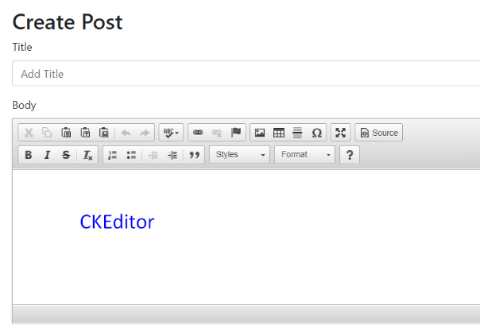

After clicking on the post, visitors will be navigated to the webpage of that posts. There are 3 different types of templates for posts according to each category. This is due to each category display different types of info hence the designs are different. Edit button and delete button will appear if the user is logged in. Bottom part contains comment section will allows visitors to post their thought. When editing or creating posts, user could use CKEditor to customize their content with different styles such as bold and italic. I used dropdown list for selecting sports and categories so that admin could only select existing option.

1. **Managing Users**

Admin and staff have same privilege except only admin could register new user. Other than that, both admin and staff could manage post, create new sport type and manage events. Furthermore, I want to assign an author when creating post so that visitors could know about the author. Besides, only author of that particular post and admin have privilege to edit or delete the post. Thus, I made adjustment to navigation bar. When user logs in as admin, an extra button is available for registering new user. The button will not appear for staff.

I also used php has password function to hash password before storing inside database. Before that, I used md5 function to hash password but I discovered due to the fast nature of this hashing algorithm, it is not suitable to use md5 function. Hence, I used hash password function.

CodeIgniter framework relies heavily on url to call function. If visitor could enter url to run function with restriction, it could be security breach. Therefore, I use session feature to determine if the visitor is log in or not. Visitor without logging in will be redirect to hamepage.

1. **Managing Events**

FunOlympic organizes two different events which are competition and sport class. I decided to combine both competition and class into one and create function for managing event. When creating new event, user has to assign event type, which is either competition or class. This method was simpler because I didn’t need to create two database tables and did extra coding. When creating event, user must assign the match round and details into title, for example, title should be Badminton Men's Singles Semi-finals. User also needs to assign location, dates, sports and types. There are only two locations, which are Stadium of Delight and Aquatic Palace.

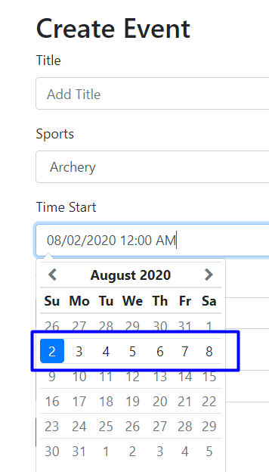When assigning dates, user is restricted to assign from 2nd of August to 8th of August. The event date must within the duration of FunOlympic, which is 1 week. This prohibit user from creating events with wrong date. Every event must be 1 hour long. User could later edit the event to update winner or delete the event.

1. **Managing Booking Events**

I choose to use JavaScript instead of php for coding to apply some booking conditions. PHP is a server-side scripting language while JavaScript is a client-side scripting language. It is easier to manipulate the html element with JavaScript. Php could do the same jobs but not effective. First, when booking to go for an event, website will check the location of visitors by tracking down location of IP address. I set the country to United Kingdom and only allow citizen of UK to book the event. The book button will disable if visitors from other countries access the webpage. I tested it by using VPN. The button will be disable.

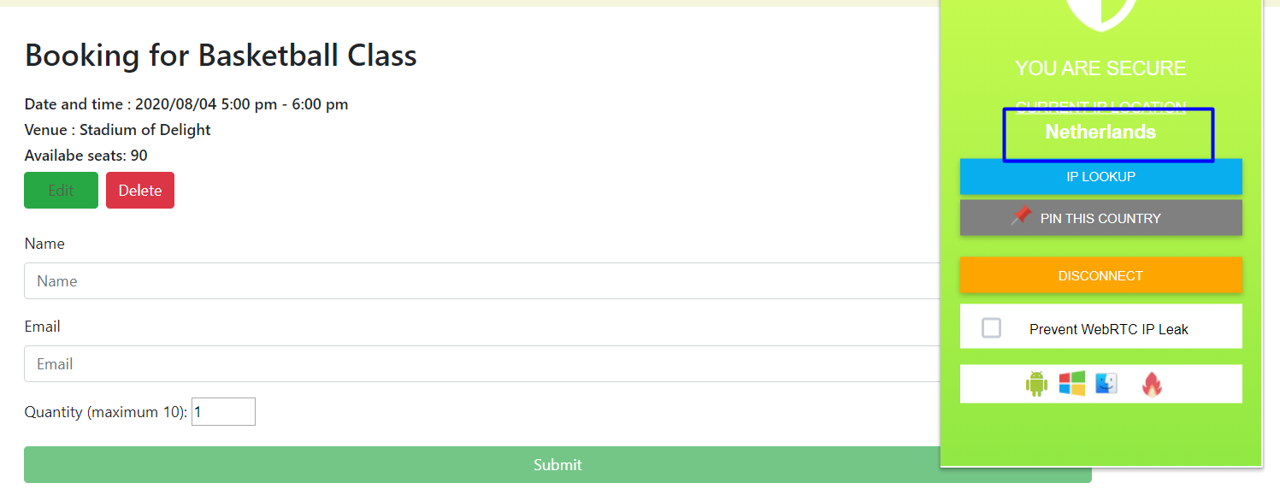

Second, visitors must the event a day ahead from the events. I used JavaScript to compare the current datetime with the event datetime. If the difference is smaller than a day or the current date exceed the event date, the book button will be disabled. Furthermore, visitors could only book for maximum for 10 people. This is to prevent a single visitor for booking all the seats. Finally, visitor could not book an event which was updated a winner.

Visitors are required to enter email to receive passcode via email. The passcode is generated by built-in function from CodeIgniter. The passcode required for entering the attending the event. When developing the function to send email, I encountered authentication problem. Luckily, I found out that if we are using Gmail, we must change to setting to allow less secure apps access in Gmail account.

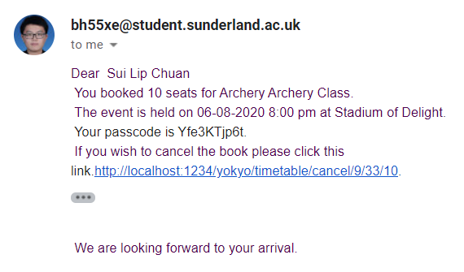

The email also provides a link to cancel booking. Visitors just need to click on the link and the system will update the Boolean field in database to false.

1. **Creating Timetable**

The Tokyo Olympic 2020 website has a timetable to display all events for a week group by sports. When planning for this function, I succeed in writing query for fetching events based on certain date. For example, I could fetch information about the events from 2nd of August group by sports. However, the query is very long and repetitive because I have to select information for 7 different dates. I could not put this whole query inside model page because it was too long and I couldn’t change to active record. It is not recommendable for displaying complete query inside model page. Hence, I created procedure inside phpMyAdmin. I simply need to call the procedure form model page to fetch information. Another limit of this query is that I could only fetch 1 field, hence I choose slug to create link to that event. User shouldn’t assign 2 events with same sports on the same day because timetable could only display 1 event in 1 column.

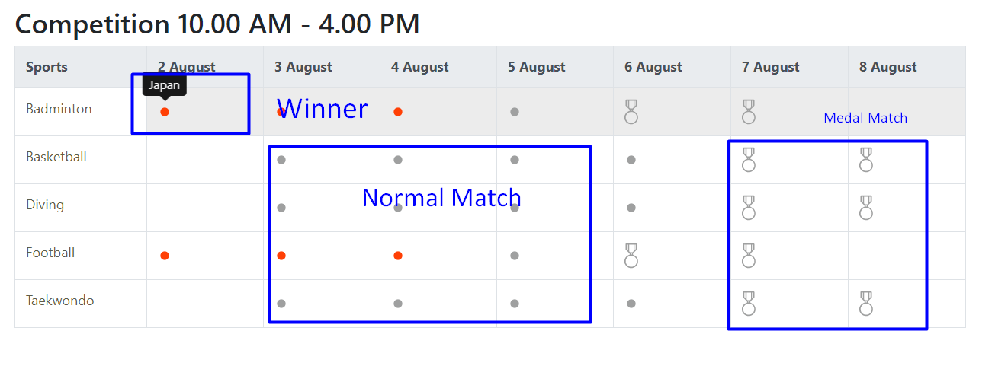

After successfully fetching information, I customized the timetable to display more information. For example, timetable will display a medal icon if the match title contains words “medal”. This indicates that the match is medal-deciding match. Furthermore, the colour of icon will change into red colour if the event is updated a winner. A tooltip will appear on that column to display the country name of winner when visitors hover their mouse.

1. **Managing Wishlist, Homepage and About Us**

I decided to add some features from Wishlist to make my website more friendly-user. First I added google translate button on navigation bar to allow visitors to translate to any language using google translation. Second, I added statistic webpage to display number of people booking for each sport. I used php json encode function to send data into template. In template, I used chart.js to display data in bar chart. Visitor could switch between sport class and competition. The link is only available to logged in user.

In homepage, I put a countdown timer to indicate the time left until FunOlympic commence. Below is a big carousel displaying multiple large and beautiful images to catch visitors’ eyes. Furthermore, the website will display newest post from each type of categories. In about us page, I briefly explained the City of Yokyo, the mascot Yogi The Bear and related locations.

Procedure for statistic, sport class and competition.

